Name: Nikita Punwatkar
PRN:24070521175

Experiment No.: 1
1.Title: Demonstration of Inline, Internal, and External JavaScript
2. Software/Tools Required: VSC,HTML,CSS
3. Theory:
Inline CSS: Inline CSS is written directly inside an HTML element using the style attribute. It is used to apply styling to a single element only. This method has the highest priority among CSS types. It is useful for quick changes but makes the code less reusable.
Internal CSS: Internal CSS is written inside the <style> tag within the <head> section of an HTML document. It is used to style multiple elements on the same webpage. This method keeps styles separate from the HTML content. It is suitable for single-page websites or small projects.
External CSS: External CSS is written in a separate .css file and linked to the HTML document using the <link> tag. It allows the same stylesheet to be used across multiple webpages. This method improves code organization and maintainability. It is the most commonly used approach in professional web development.
CODE:
<html>
<head>
<title>My Profile</title>
<style>
body{
font-family: Arial;
background:#f2f2f2;
}

.card{
width:350px;
margin:80px auto;
padding:20px;
background:white;
border-radius:10px;
text-align:center;
box-shadow:0 0 10px gray;
}

button{
padding:10px 15px;
margin:8px;
border:none;
border-radius:5px;
background:blue;
color:white;
cursor:pointer;
}

button:hover{
background:green;
}
</style>
</head>
<body>

<div class="card">
<h2>Welcome!</h2>

<p><b>Name:</b> Ayushi Ray</p>
<p><b>PRN No:</b> 24070521145</p>
<p><b>Course:</b> B.Tech CSE</p>
<p><b>College:</b> SIT Nagpur</p>

<button onclick = "console.log('Welcome Nikita Punwatkar'); alert('Welcome, Nikita Punwatkar' Inline executed')"> Inline CSS </button>
<button>Internal CSS</button>
<button onclick = "console.log('Welcome Nikita Punwatkar'); alert('Welcome, Nikita Punwatkar'External executed')"> External CSS</button>
</div>

<script>
console.log("Welcome to my webpage!"); alert()
</script>

</body>
</html>

Output :
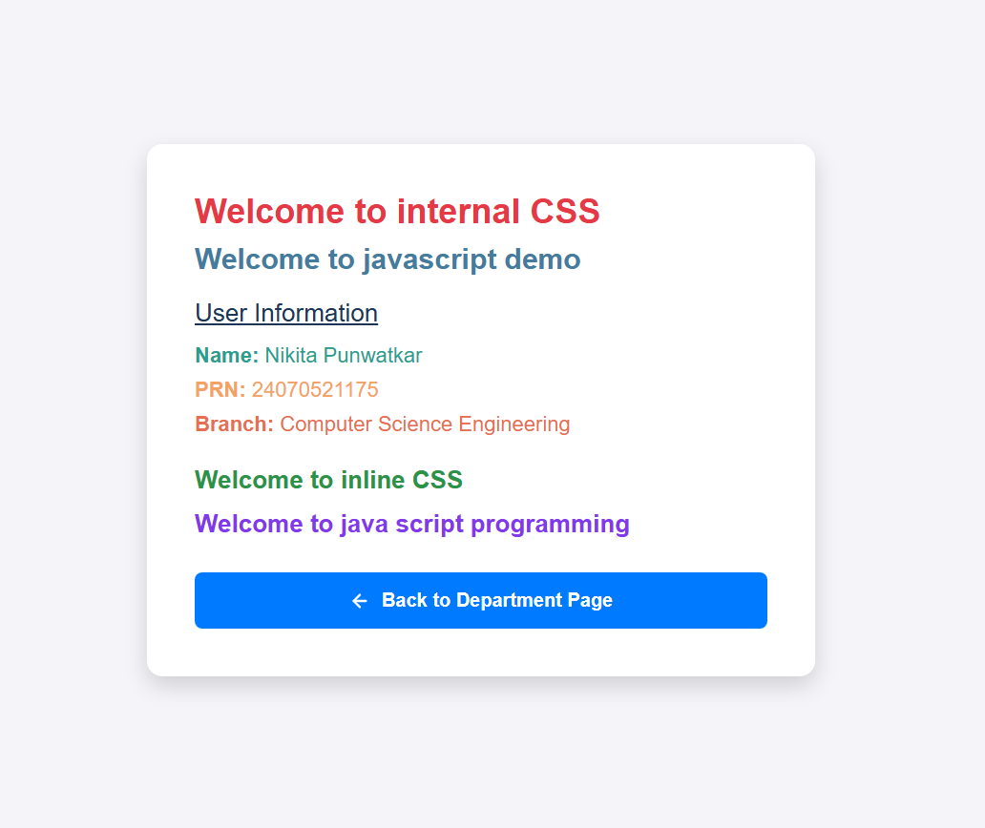


5. Result/Conclusion:
The webpage was successfully created using inline, internal, and external CSS. Different styling methods were implemented and compared, and the webpage displayed the required content with the desired formatting.

Experiment No.: 2
1. Title:
Use of var, let, const, Template Literals, and Destructuring by Building a Billing Calculator with User Input
2. Software/Tools Required:
VS Code, HTML, CSS, JavaScript, Web Browser (Google Chrome/Microsoft Edge)
3. Theory:
var:
var is used to declare variables in JavaScript. Its function scope and can be redeclared and updated. It is mainly used in older JavaScript programs, though modern code generally prefers let and const.
let:
let is used to declare variables whose values may change during program execution. It has block scope and cannot be redeclared within the same block. It is commonly used for variables such as quantity, rate, and discount that change based on user input.
const:
const is used to declare constant values that do not change after initialization. It also has block scope. It is suitable for fixed values such as the tax rate or other constant settings used in the billing calculator.
Template Literals:
Template literals are strings enclosed in backticks ( ). They allow variables and expressions to be embedded directly inside strings using ${}. This makes it easier to display formatted invoice details and output messages.
Destructuring:
Destructuring is a JavaScript feature used to extract values from objects or arrays into separate variables. It simplifies the code and improves readability by reducing repetitive object property access.
Billing Calculator:
A billing calculator accepts user inputs such as customer name, service name, quantity, rate, and discount. It performs calculations to determine the total bill amount and displays the invoice in a user-friendly format. This experiment demonstrates the practical use of modern JavaScript features while handling user input and calculations.

4. Code:
!DOCTYPE html>
<html lang="en">
<head>
<meta charset="UTF-8" />
<meta name="viewport" content="width=device-width, initial-scale=1.0" />
<title>Billing Calculator</title>
<style>
body {
font-family: Arial, sans-serif;
background: linear-gradient(135deg, #e8f0ff, #f9fbff);
margin: 0;
padding: 0;
color: #1f2937;
}

.container {
max-width: 720px;
margin: 40px auto;
background: white;
padding: 24px;
border-radius: 16px;
box-shadow: 0 8px 24px rgba(0, 0, 0, 0.1);
}

h1 {
margin-top: 0;
color: #2563eb;
}

form {
display: grid;
gap: 12px;
}

label {
display: flex;
flex-direction: column;
font-weight: bold;
gap: 6px;
}

input {
padding: 10px;
border: 1px solid #cbd5e1;
border-radius: 8px;
font-size: 15px;
}

button {
padding: 12px 16px;
border: none;
border-radius: 8px;
background: #2563eb;
color: white;
font-size: 16px;
cursor: pointer;
margin-top: 8px;
}

button:hover {
background: #1d4ed8;
}

.result {
margin-top: 20px;
padding: 16px;
background: #eff6ff;
border-left: 5px solid #2563eb;
border-radius: 8px;
}

.notes {
margin-top: 20px;
background: #f8fafc;
padding: 14px;
border-radius: 8px;
}
</style>
</head>
<body>
<div class="container">
<h1 id="title">Billing Calculator</h1>
<p>Enter the details below to calculate a simple invoice.</p>

resultBox.innerHTML = `
<h3>Invoice for ${name}</h3>
<p><strong>Service:</strong> ${service}</p>
<p><strong>Quantity:</strong> ${quantity}</p>
<p><strong>Rate:</strong> $${rate.toFixed(2)}</p>
<p><strong>Discount:</strong> ${discount}%</p>
<p><strong>Subtotal:</strong> $${subtotal.toFixed(2)}</p>
<p><strong>Tax (${(TAX_RATE * 100).toFixed(0)}%):</strong> $${taxAmount.toFixed(2)}</p>
<p><strong>Total:</strong> $${totalAmount.toFixed(2)}</p>
`;
});
</script>
</body>
</html>

5. Output:
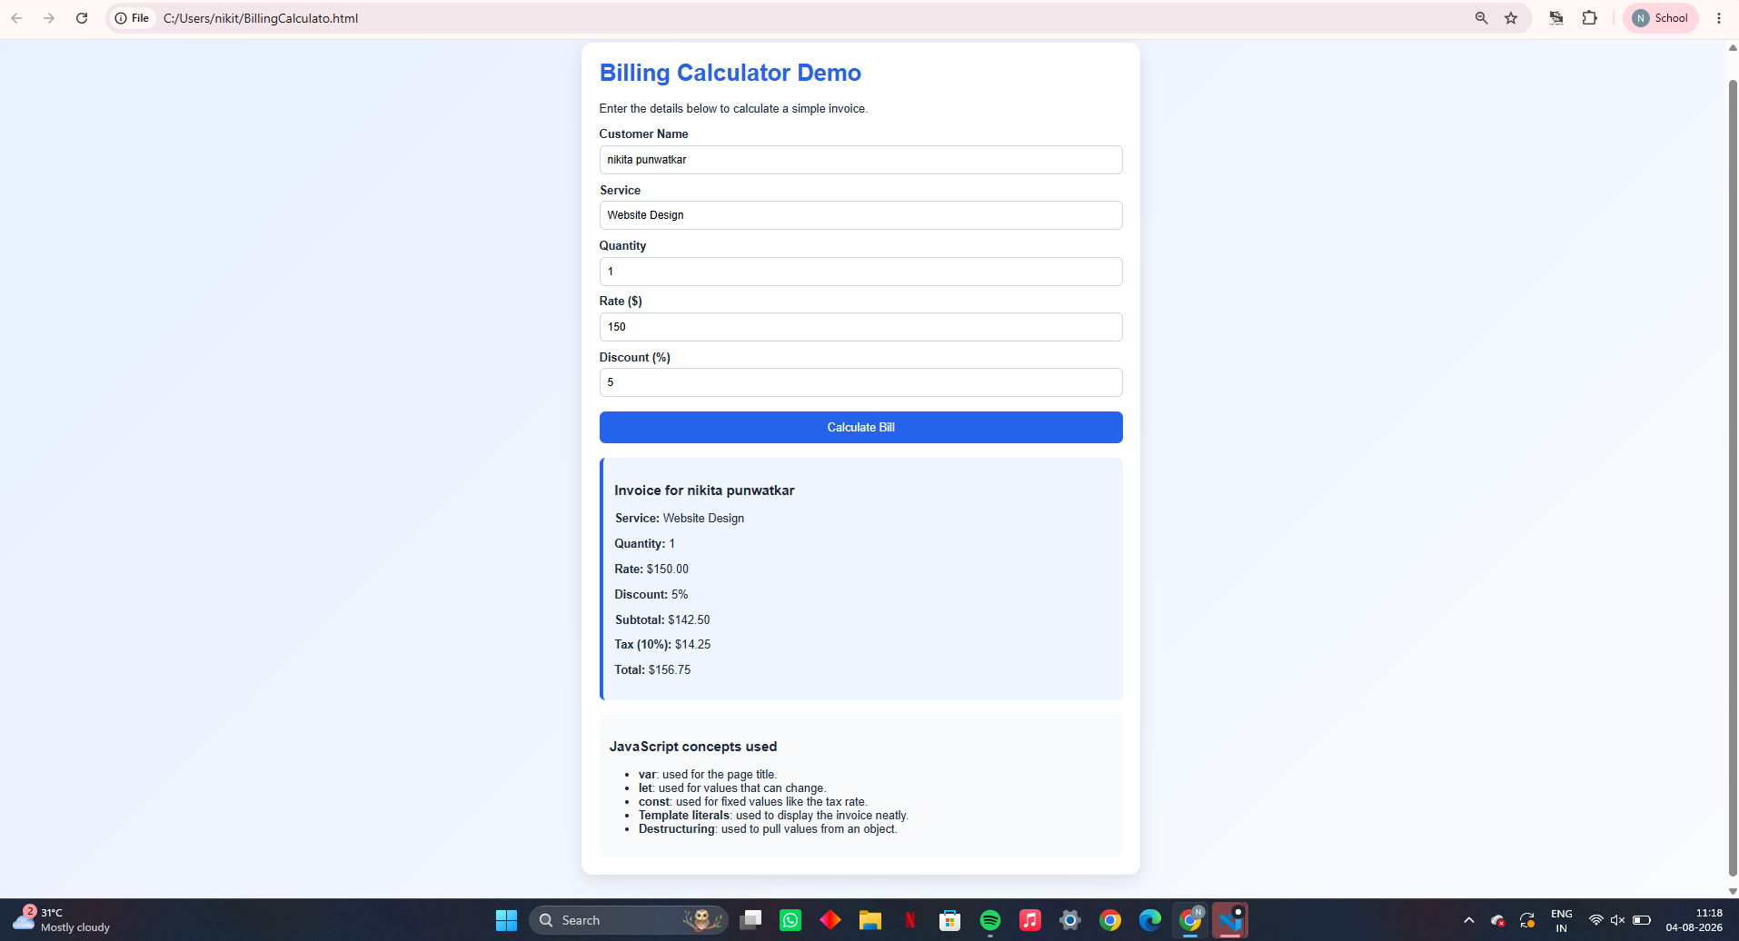

CASE STUDY : Develop the webpage for an online shopping website with using html,css and html tags and calculate bill,customer name,mobile no,invoice no,product no,quantity(kg),rate per kg,discount,GST,packing charges,payment mode(cash/card/UPI), Membership(yes/no).
- CODE:
<!DOCTYPE html>
<html lang="en">
<head>
<meta charset="UTF-8" />
<meta name="viewport" content="width=device-width, initial-scale=1.0" />
<title>Online Shopping Billing</title>
<style>
body {
font-family: Arial, sans-serif;
margin: 0;
background: linear-gradient(135deg, #fdf2f8, #eef2ff);
color: #111827;
}

.container {
max-width: 900px;
margin: 30px auto;
background: white;
border-radius: 16px;
box-shadow: 0 8px 24px rgba(0,0,0,0.12);
padding: 24px;
}

h1, h2 {
color: #7c3aed;
}

.grid {
display: grid;
grid-template-columns: 1fr 1fr;
gap: 20px;
}

.box {
background: #f9fafb;
padding: 16px;
border-radius: 12px;
}

label {
display: flex;
flex-direction: column;
margin-bottom: 10px;
font-weight: bold;
gap: 6px;
}

input, select {
padding: 10px;
border: 1px solid #d1d5db;
border-radius: 8px;
font-size: 15px;
}

button {
padding: 12px 16px;
border: none;
border-radius: 8px;
background: #7c3aed;
color: white;
cursor: pointer;
font-size: 16px;
margin-top: 8px;
}

button:hover {
background: #6d28d9;
}

.invoice {
margin-top: 20px;
background: #f5f3ff;
border-left: 5px solid #7c3aed;
padding: 16px;
border-radius: 10px;
}

.small {
font-size: 14px;
color: #4b5563;
}
</style>
</head>
<body>
<div class="container">
<h1>Online Shopping Billing System</h1>
<p>Fill in the customer details and product information to generate a bill.</p>

<div class="grid">
<div class="box">
<h2>Customer Details</h2>
<label>Customer Name
<input type="text" id="customerName" placeholder="Enter name" />
</label>
<label>Mobile No.
<input type="text" id="mobileNo" placeholder="Enter mobile number" />
</label>
<label>Invoice No.
<input type="text" id="invoiceNo" placeholder="Enter invoice number" />
</label>
<label>Product No.
<input type="text" id="productNo" placeholder="Enter product number" />
</label>
</div>

<div class="box">
<h2>Product Details</h2>
<label>Quantity (kg)
<input type="number" id="quantity" min="1" value="1" />
</label>
<label>Rate per kg (₹)
<input type="number" id="rate" min="0" step="0.01" value="100" />
</label>
<label>Discount (%)
<input type="number" id="discount" min="0" max="100" value="0" />
</label>
<label>GST (%)
<input type="number" id="gst" min="0" max="100" value="5" />
</label>
<label>Packing Charges (₹)
<input type="number" id="packingCharges" min="0" step="0.01" value="10" />
</label>
<label>Payment Mode
<select id="paymentMode">
<option value="Cash">Cash</option>
<option value="Card">Card</option>
<option value="UPI">UPI</option>
</select>
</label>
<label>Membership
<select id="membership">
<option value="No">No</option>
<option value="Yes">Yes</option>
</select>
</label>
</div>
</div>

<button onclick="calculateBill()">Generate Bill</button>

<div id="invoiceOutput" class="invoice">
<h2>Invoice</h2>
<p class="small">Your bill will appear here.</p>
</div>
</div>

<script>

}
</script>
</body>
</html>
- Output:
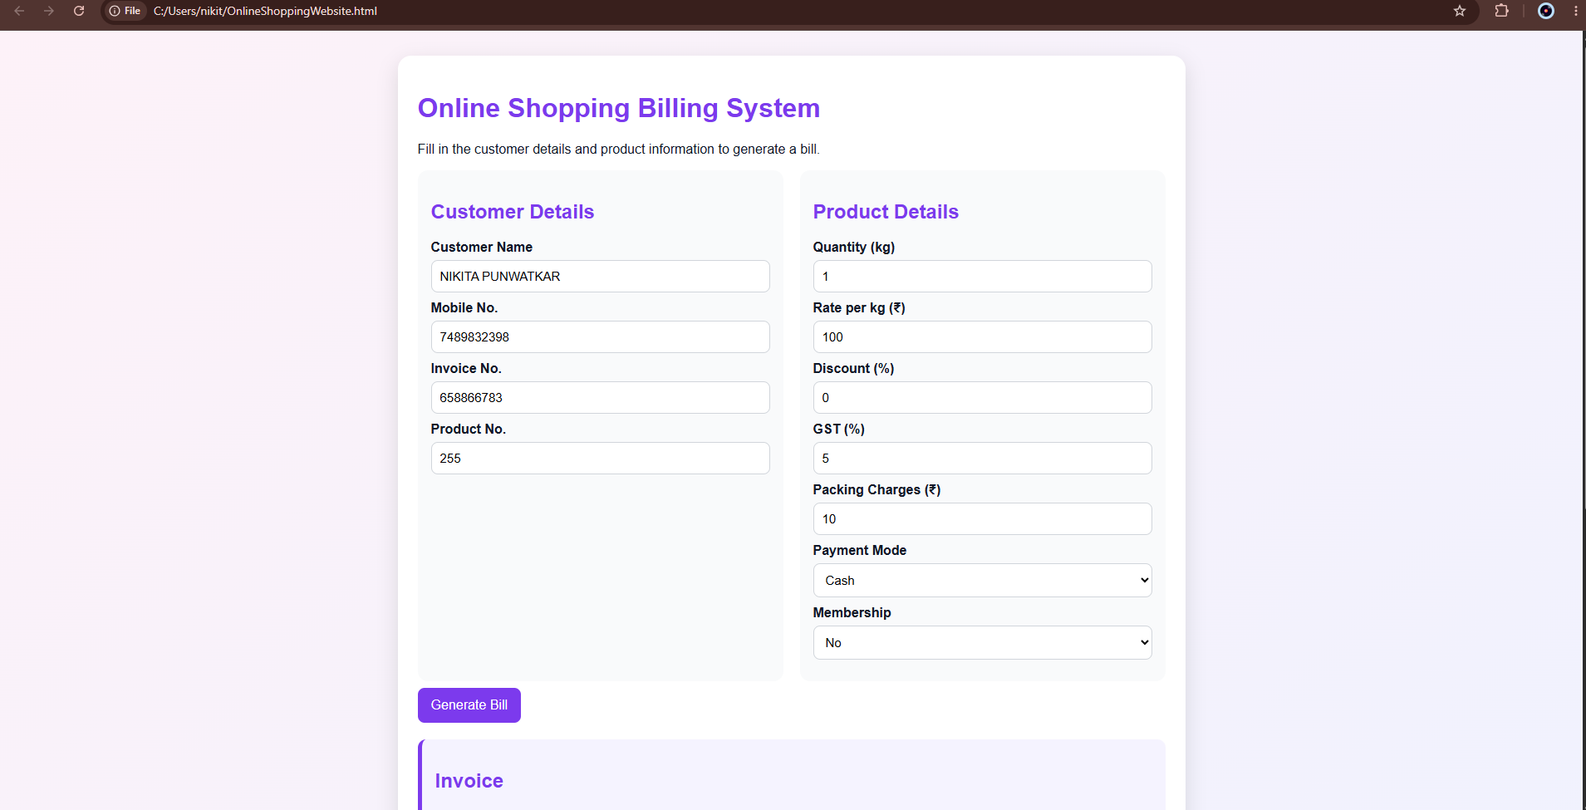

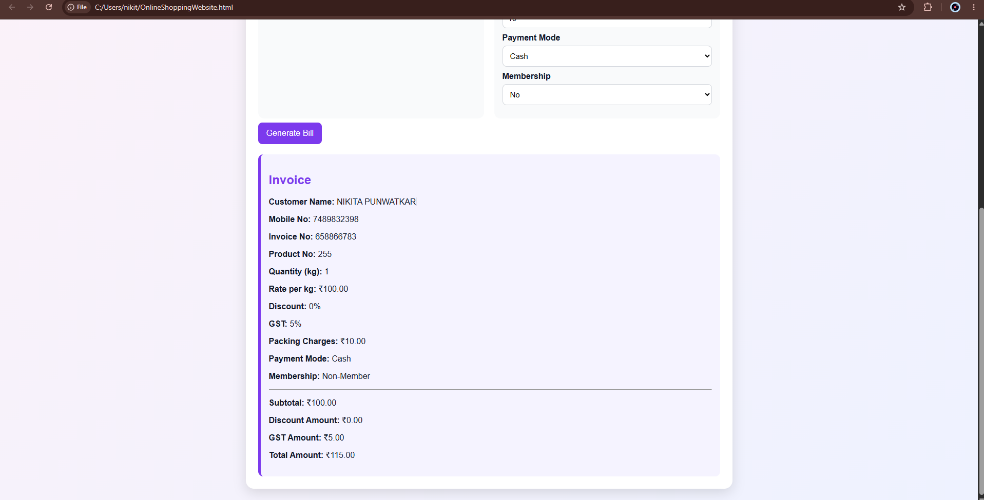

Experiment No.: 3
1. Title:
Implementation of Control Structures and Form Validation by Creating a Grading System Based on User-Entered Marks
2. Software/Tools Required:
VS Code, HTML, CSS, JavaScript, Web Browser (Google Chrome/Microsoft Edge)
3. Theory:
Control Structures:
Control structures determine the flow of execution in a JavaScript program. Decision-making statements such as if, else if, and else are used to execute different blocks of code based on conditions. In this experiment, control structures are used to assign grades according to the marks entered by the user.
Form Validation:
Form validation is the process of checking whether the data entered by the user is valid before processing it. It ensures that required fields are not left empty and that the entered marks are within the valid range (0–100). Validation improves data accuracy and prevents invalid inputs.
if-else Statements:
The if, else if, and else statements evaluate conditions and execute the appropriate code block. In the grading system, these statements compare the entered marks with predefined ranges and assign the corresponding grade.
User Input Handling:
JavaScript retrieves values entered by the user through HTML form elements. The input is validated, converted into numeric values, and processed to determine the student's grade.
Grading System:
A grading system classifies student performance based on marks. For example:
- 90–100: Grade A
- 80–89: Grade B
- 70–79: Grade C
- 60–69: Grade D
- Below 60: Grade F
The system automatically evaluates the entered marks and displays the appropriate grade along with validation messages if necessary.

4. CODE:
<!DOCTYPE html>
<html lang="en">
<head>
<meta charset="UTF-8" />
<meta name="viewport" content="width=device-width, initial-scale=1.0" />
<title>Grading System</title>
<style>
body {
font-family: Arial, sans-serif;
background: linear-gradient(135deg, #fdf2f8, #eff6ff);
margin: 0;
padding: 0;
color: #111827;
}

.container {
max-width: 700px;
margin: 40px auto;
background: white;
padding: 24px;
border-radius: 16px;
box-shadow: 0 8px 24px rgba(0, 0, 0, 0.12);
}

if (marks >= 90) {
grade = "A+";
remark = "Excellent work!";
} else if (marks >= 80) {
grade = "A";
remark = "Very good performance.";
} else if (marks >= 70) {
grade = "B";
remark = "Good effort.";
} else if (marks >= 60) {
grade = "C";
remark = "Satisfactory.";
} else if (marks >= 40) {
grade = "D";
remark = "Needs improvement.";
} else {
grade = "F";
remark = "Fail. Please review the subject again.";
}
</script>
</body>
</html>

5. Output:
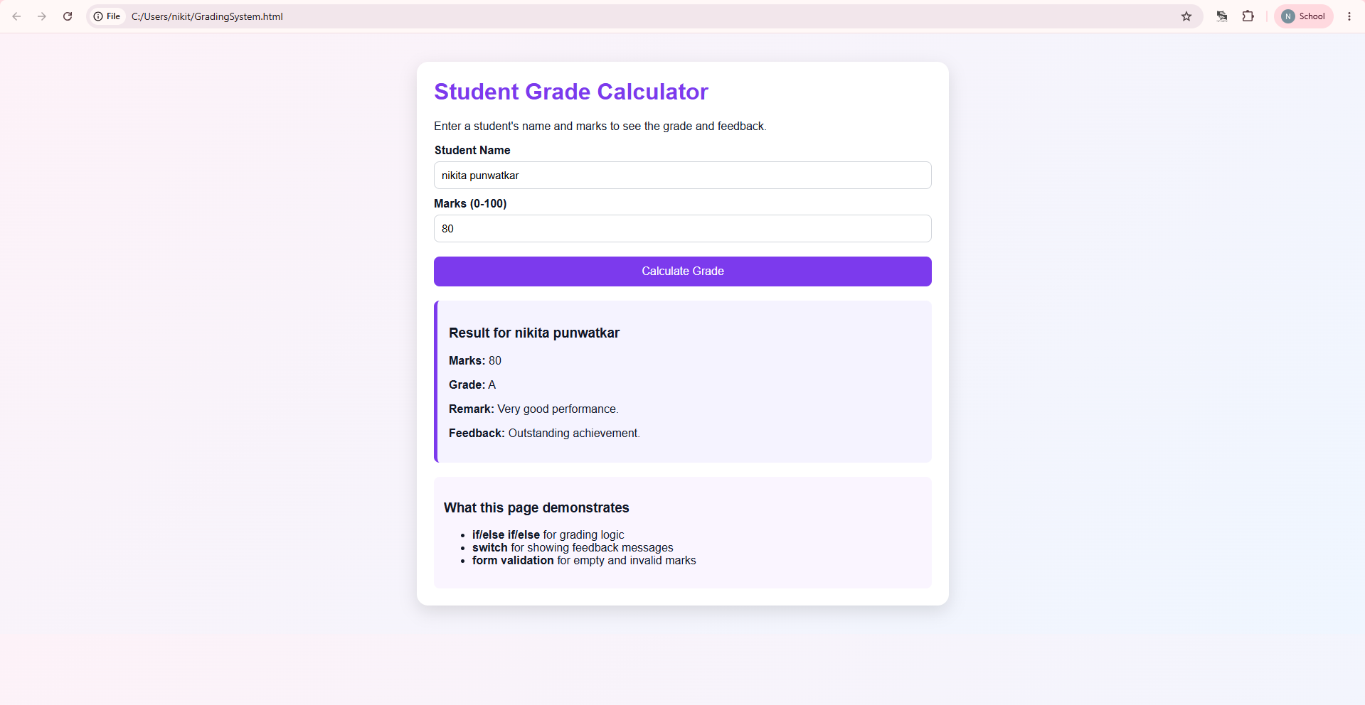

5. Result/Conclusion:
The grading system was successfully developed using HTML, CSS, and JavaScript. User input was validated to ensure that only valid marks were accepted, and control structures (if, else if, and else) were used to assign grades accurately. The experiment demonstrated the effective implementation of form validation and decision-making statements in creating an interactive web application.

CASE STUDY: Scholarship Eligibility, A college awards scholarships based on marks. Below 50-Not Eligible, 50-69-Bronze,70-84-Silver,85-94-Gold,95-100-Platinum. Write a JavaScript program that accepts student marks and display the Scholarship category.
CODE:
<!DOCTYPE html>
<html lang="en">
<head>
<meta charset="UTF-8" />
<meta name="viewport" content="width=device-width, initial-scale=1.0" />
<title>Scholarship Eligibility</title>
<style>
body {
font-family: Arial, sans-serif;
margin: 0;
background: linear-gradient(135deg, #fefce8, #eff6ff);
color: #111827;
}
if (marks < 50) {
category = 'Not Eligible';
} else if (marks >= 50 && marks <= 69) {
category = 'Bronze';
} else if (marks >= 70 && marks <= 84) {
category = 'Silver';
} else if (marks >= 85 && marks <= 94) {
category = 'Gold';
} else {
category = 'Platinum';
}

resultBox.textContent = `Scholarship Category: ${category}`;
}
</script>
</body>
</html>

OUTPUT:
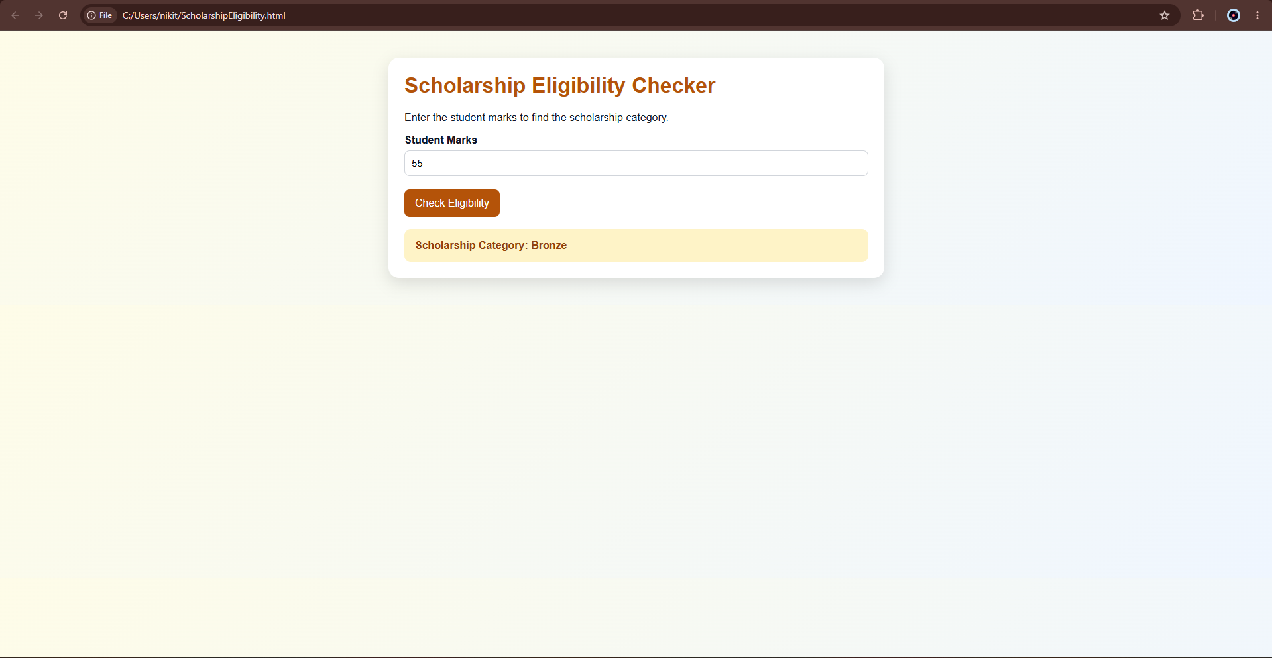

Experiment No.: 4
1. Title:
Use of Function Types, Scope, Closures, and Exception Handling (try-catch) by Building a Palindrome Checker
2. Software/Tools Required:
VS Code, HTML, CSS, JavaScript, Web Browser (Google Chrome/Microsoft Edge)
3. Theory:
Functions in JavaScript:
Functions are reusable blocks of code that perform a specific task. JavaScript supports different types of functions, such as function declarations, function expressions, and arrow functions. Functions improve code reusability, readability, and modularity.
Variable Scope:
Scope determines where a variable can be accessed in a program. JavaScript provides global scope, function scope, and block scope. Variables declared using let and const have block scope, while var has function scope. Proper use of scope helps avoid naming conflicts and improves program organization.
Closures:
A closure is a function that remembers and can access variables from its outer (enclosing) scope even after the outer function has finished executing. Closures are useful for data encapsulation, maintaining private variables, and preserving state between function calls.
Exception Handling (try-catch):
The try-catch statement is used to handle runtime errors gracefully. Code that may generate an error is placed inside the try block, while the catch block handles any exceptions without stopping the execution of the program. This improves the reliability and user experience of the application.
Palindrome Checker:
A palindrome is a word, phrase, or number that reads the same forward and backward after ignoring spaces, punctuation, and letter case. A palindrome checker accepts user input, processes the text, and determines whether it is a palindrome. This experiment demonstrates the use of functions, variable scope, closures, and exception handling while validating and processing user input.

4. Output:
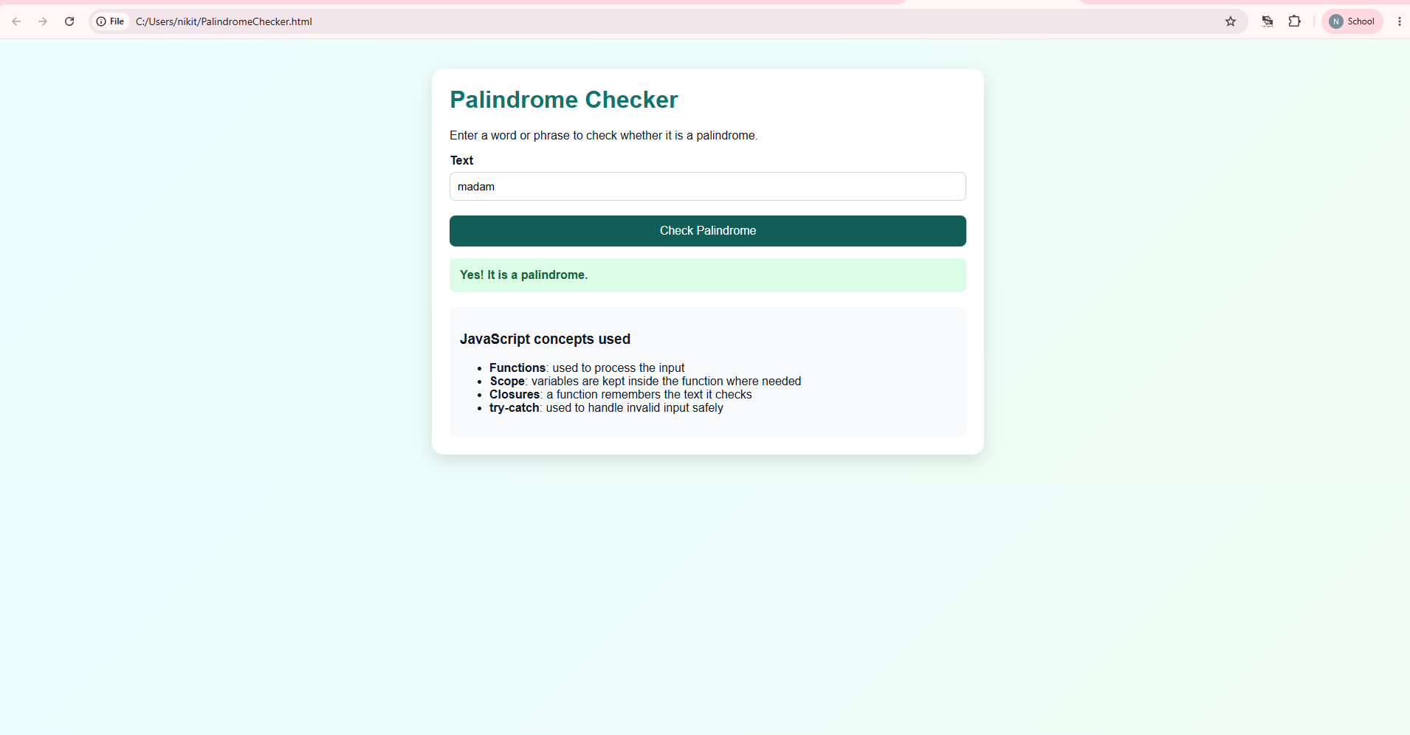
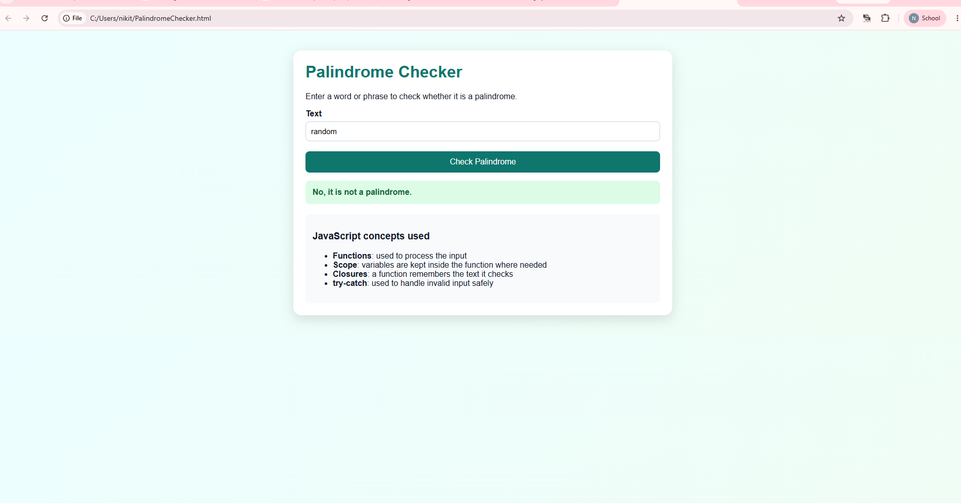

5. Result/Conclusion:
The palindrome checker was successfully developed using HTML, CSS, and JavaScript. Different function types were implemented to perform the palindrome check, while variable scope and closures were used to organize the program efficiently. Exception handling using try-catch ensured that invalid inputs were handled gracefully. The experiment demonstrated the practical application of JavaScript functions, scope, closures, and error handling in building an interactive web application.

CASE STUDY:
CODE: !DOCTYPE html>
<html lang="en">
<head>
<meta charset="UTF-8" />
<meta name="viewport" content="width=device-width, initial-scale=1.0" />
<title>Password Palindrome Checker</title>
<style>
body {
font-family: Arial, sans-serif;
background: linear-gradient(135deg, #fef2f2, #f0fdfa);
margin: 0;
padding: 0;
color: #111827;
}

.container {
max-width: 700px;
margin: 40px auto;
background: white;
padding: 24px;
border-radius: 16px;
box-shadow: 0 8px 24px rgba(0, 0, 0, 0.12);
}

h1 {
color: #b91c1c;
margin-top: 0;
}

form {
display: grid;
gap: 12px;
}

label {
display: flex;
flex-direction: column;
font-weight: bold;
gap: 6px;
}

input {
padding: 10px;
border: 1px solid #d1d5db;
border-radius: 8px;
font-size: 15px;
}

button {
padding: 12px 16px;
border: none;
border-radius: 8px;
background: #b91c1c;
color: white;
font-size: 16px;
cursor: pointer;
margin-top: 8px;
}

button:hover {
background: #991b1b;
}

.message {
margin-top: 16px;
padding: 14px;
border-radius: 8px;
font-weight: bold;
}

.success {
background: #dcfce7;
color: #166534;
}

.error {
background: #fee2e2;
color: #b91c1c;
}

.info {
margin-top: 12px;
color: #4b5563;
}
</style>
</head>
<body>
<div class="container">
}

<script>
</script>
</body>
</html>

OUTPUT:
